# Question 1

## Question 1.1

**Visualization 1.1.1**

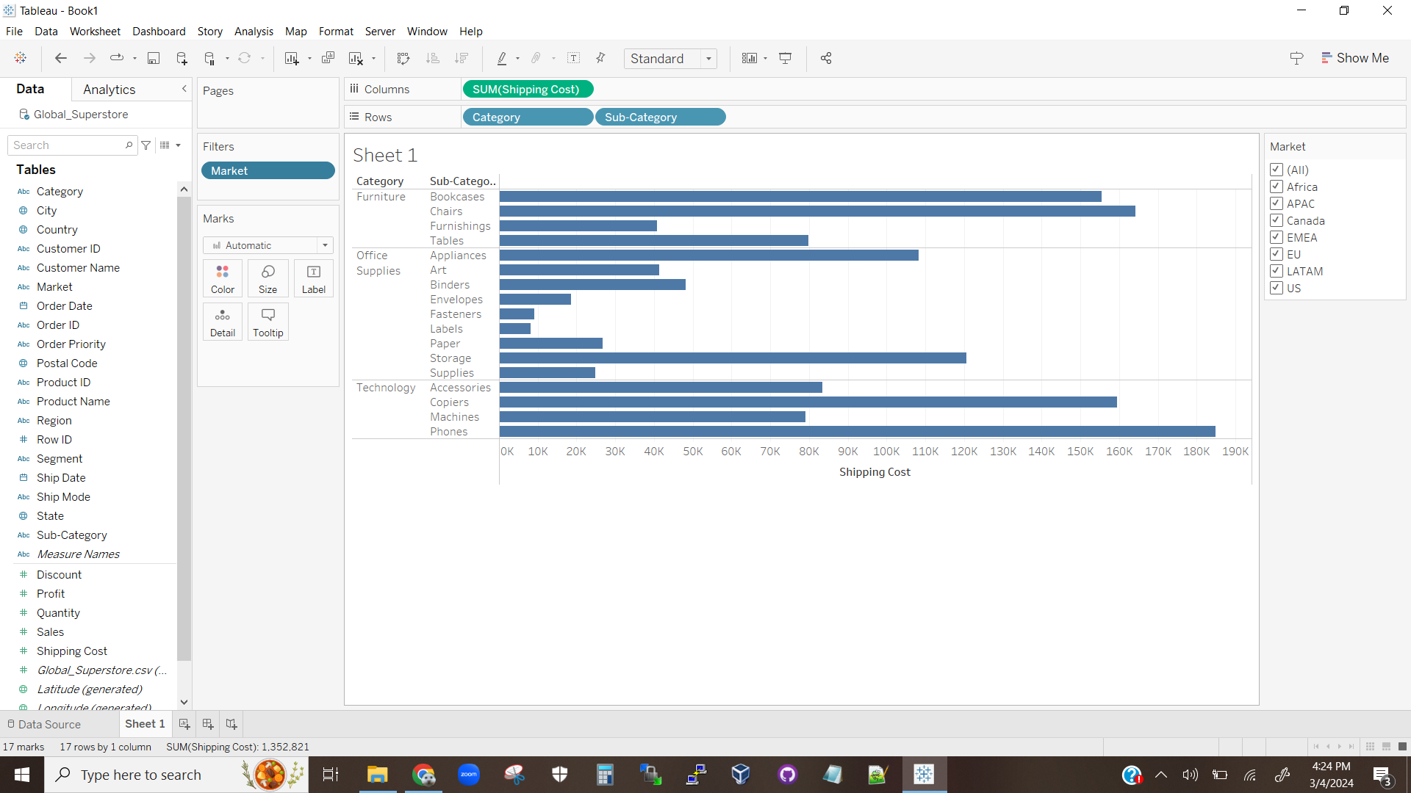

The above visualization is a bar chart showing the sales totals of each sub-category for all markets, grouped by category.

**Visualization 1.1.2**

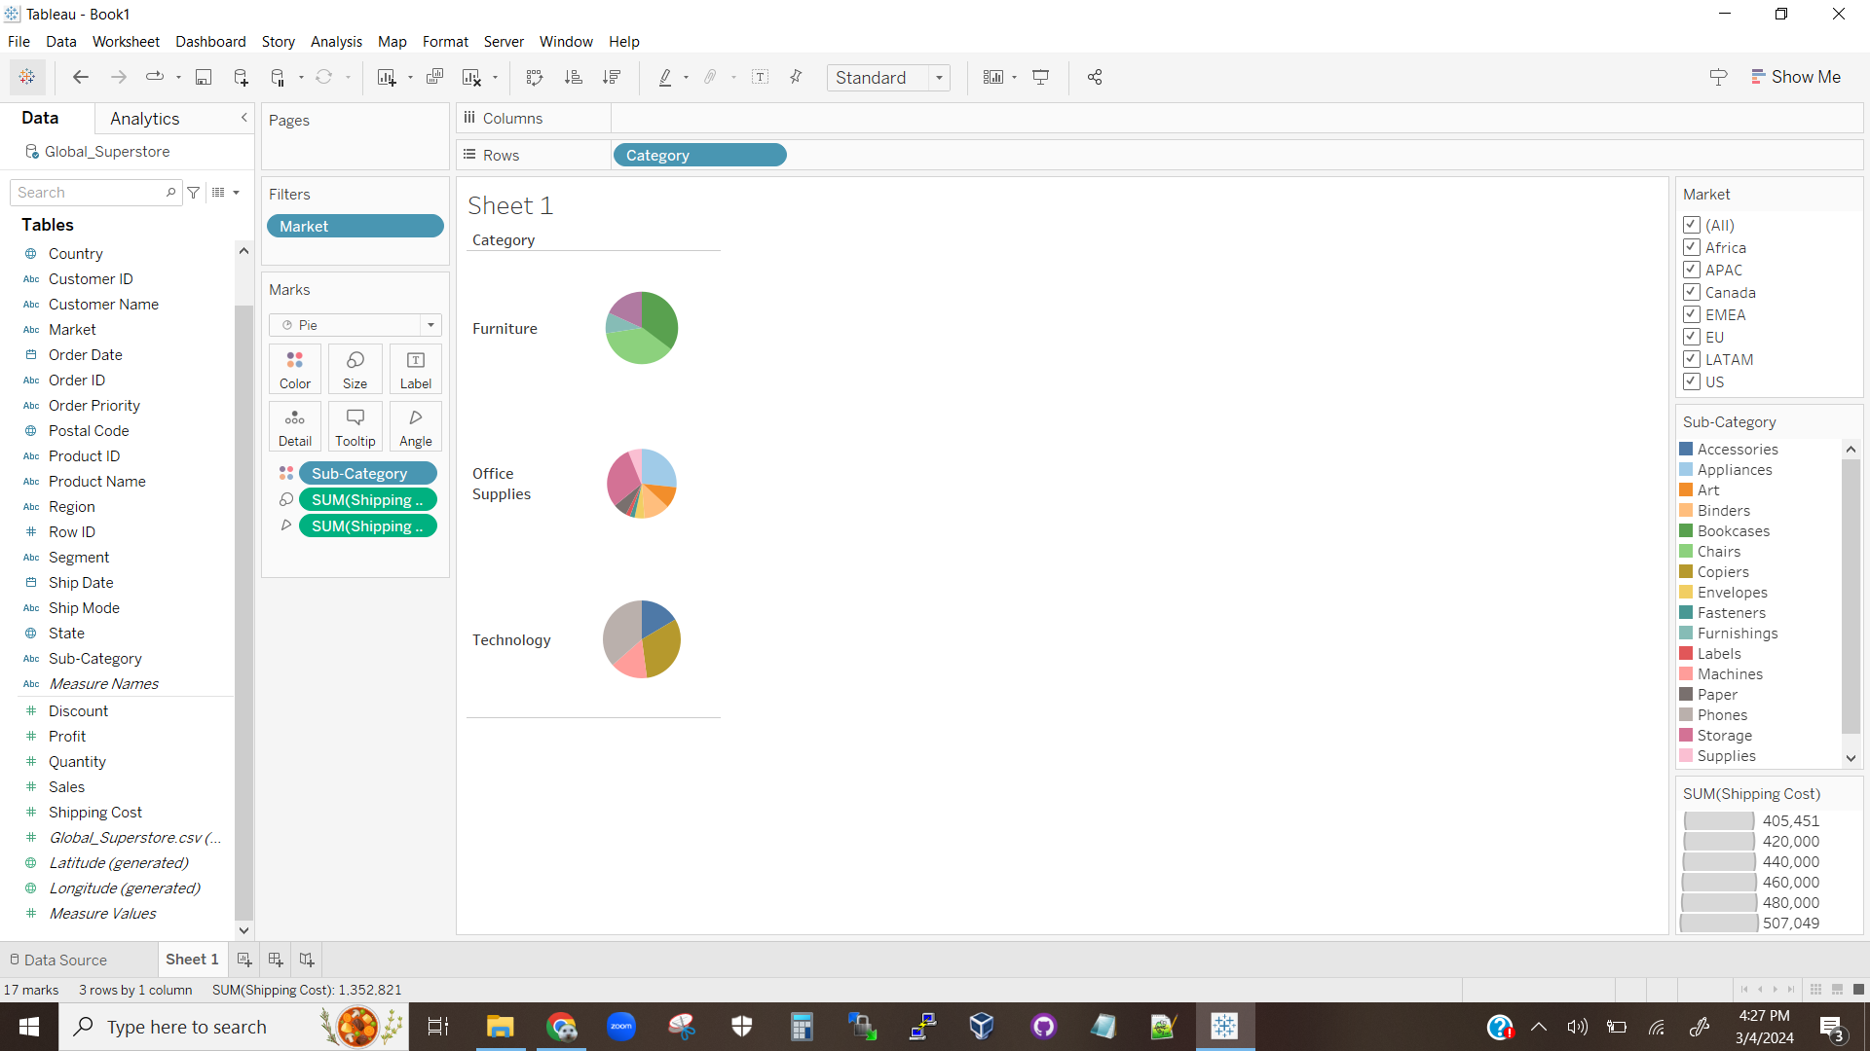

The above visualization is a series of pie charts displaying what percentage of the total shipping costs per category each sub-category takes up. Additionally, the relative sizes of each pie chart indicate the relative total shipping costs between categories.

## Question 1.2

Based on visualization 1.1.1 it is clear that the furniture and technology categories have the four highest costing sub-categories within them. Office supplies has the most low shipping cost sub-categories. However, it does have the most sub-categories and also has a few high cost and average cost sub-categories. As can be seen in visualization 1.1.2, these extra sub-categories and higher cost sub-categories bring the relative costs between each category to be roughly even. Visualization 1.1.2 also shows that the relative low costs of many categories in the office supplies category do eventually add up, with the relative size of the whole pie cart not being far off of the size for the technology and the furniture categories. It can also be noticed that, based on visualization 1.1.1, for the most part the high shipping cost items are also physically large items. The main sub-category that is the exception to this trend is phones, which likely receive extra care with packaging and shipping due to the high value of cell phones. An interesting exception in the opposite direction is tables. The sub-category only has an average to high shipping cost, despite being a large item. This could be because tables can be disassembled and are rather flat once in pieces, reducing the space needed for each disassembled table.

## Question 1.3

**Visualization 1.3.1**

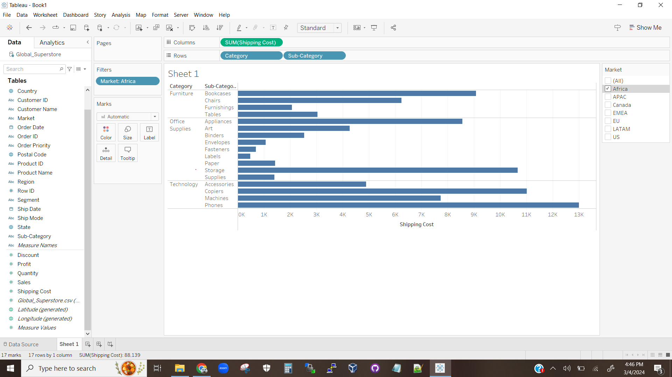

The above visualization shows the total shipping cost of each sub-category for the African market.

**Visualization 1.3.2**

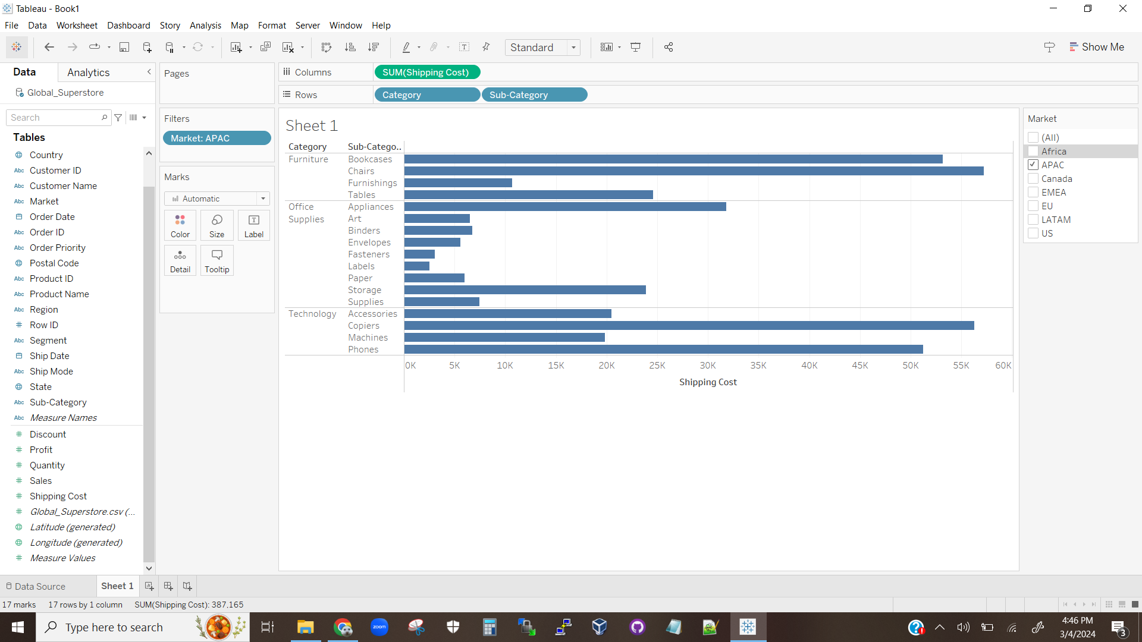

The above visualization shows the total shipping cost of each sub-category for the APAC market.

**Visualization 1.3.3**

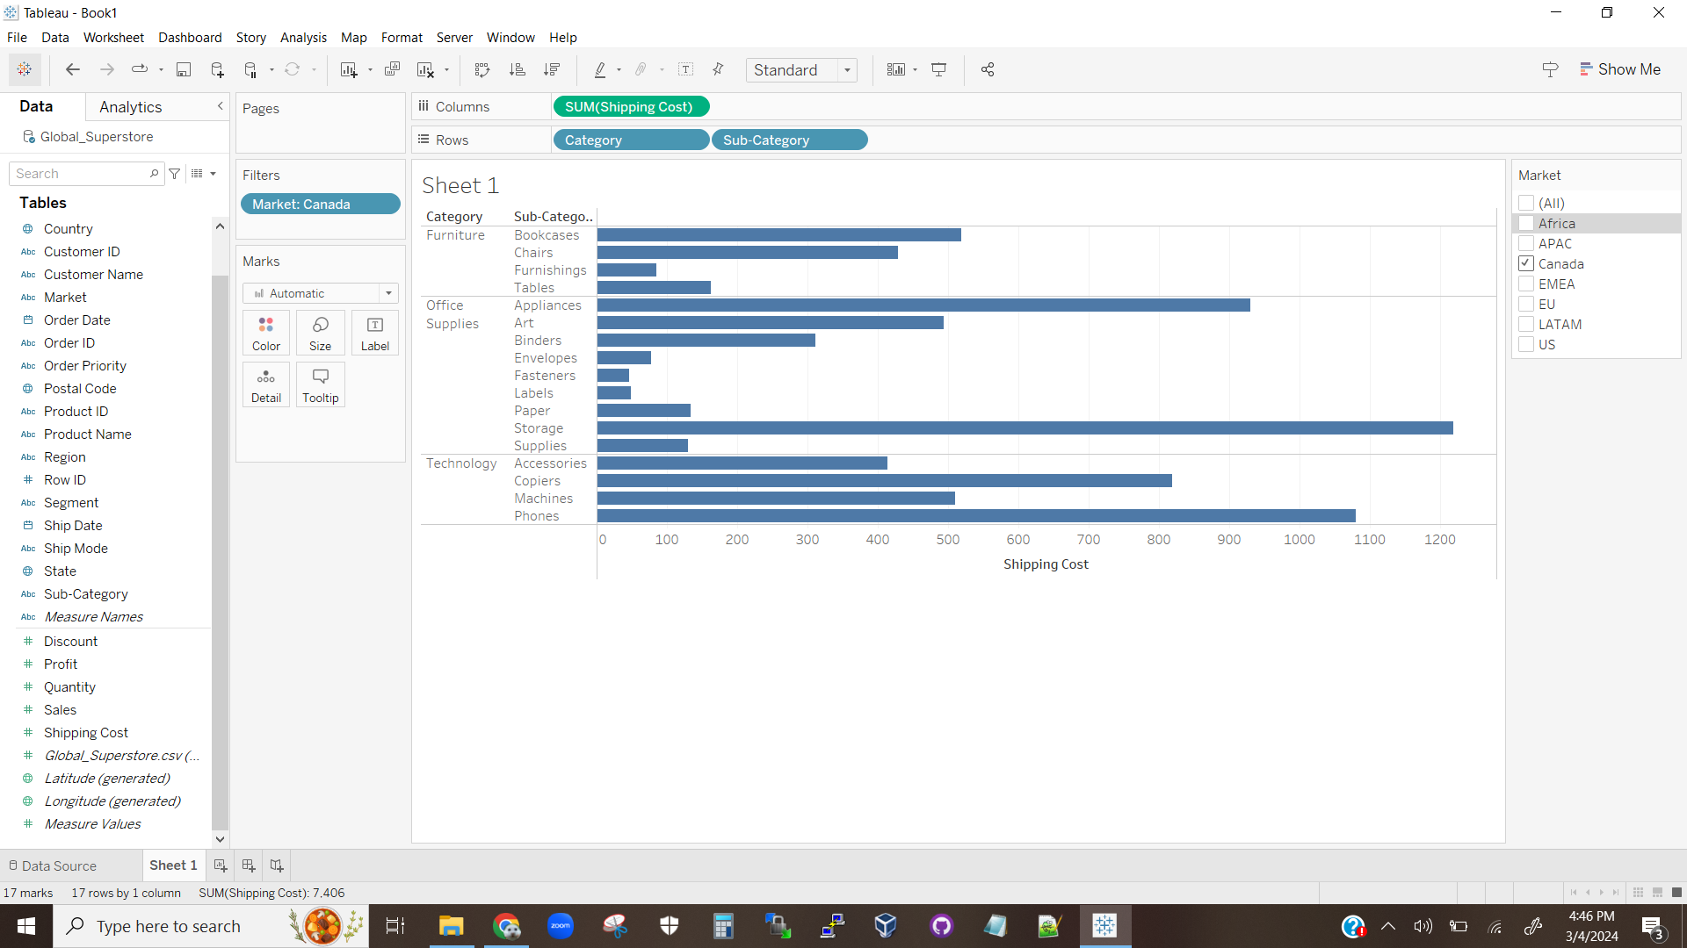

The above visualization shows the total shipping cost of each sub-category for the Canadian market.

**Visualization 1.3.4**

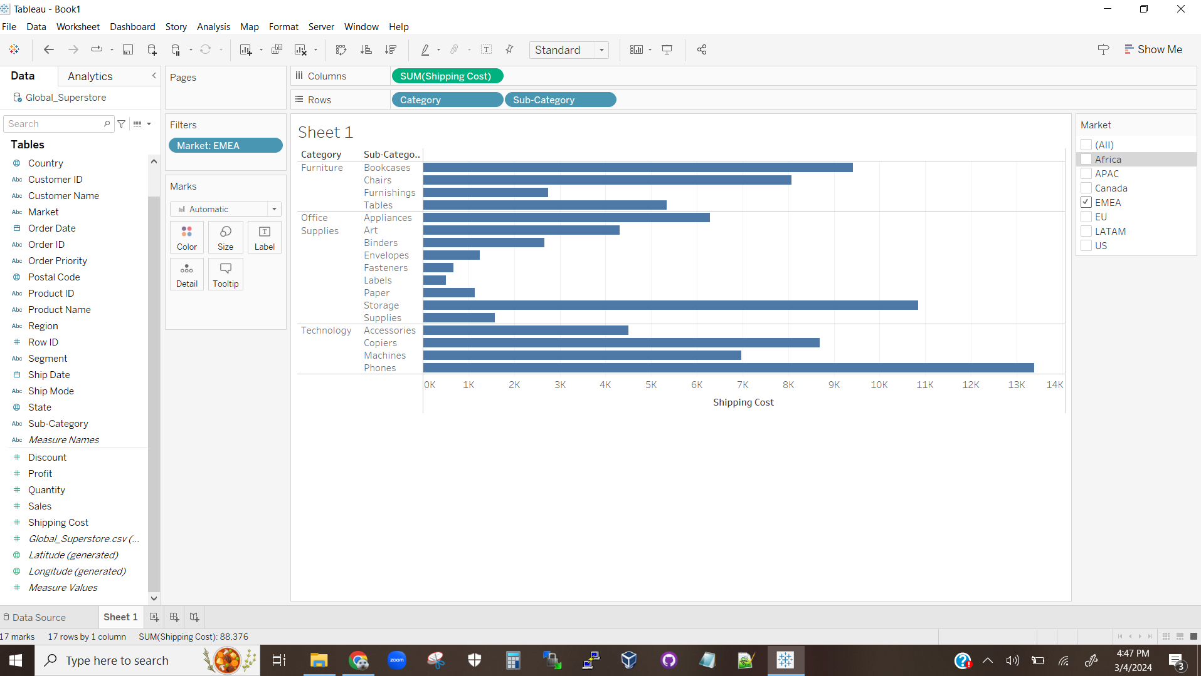

The above visualization shows the total shipping cost of each sub-category for the EMEA market.

**Visualization 1.3.5**

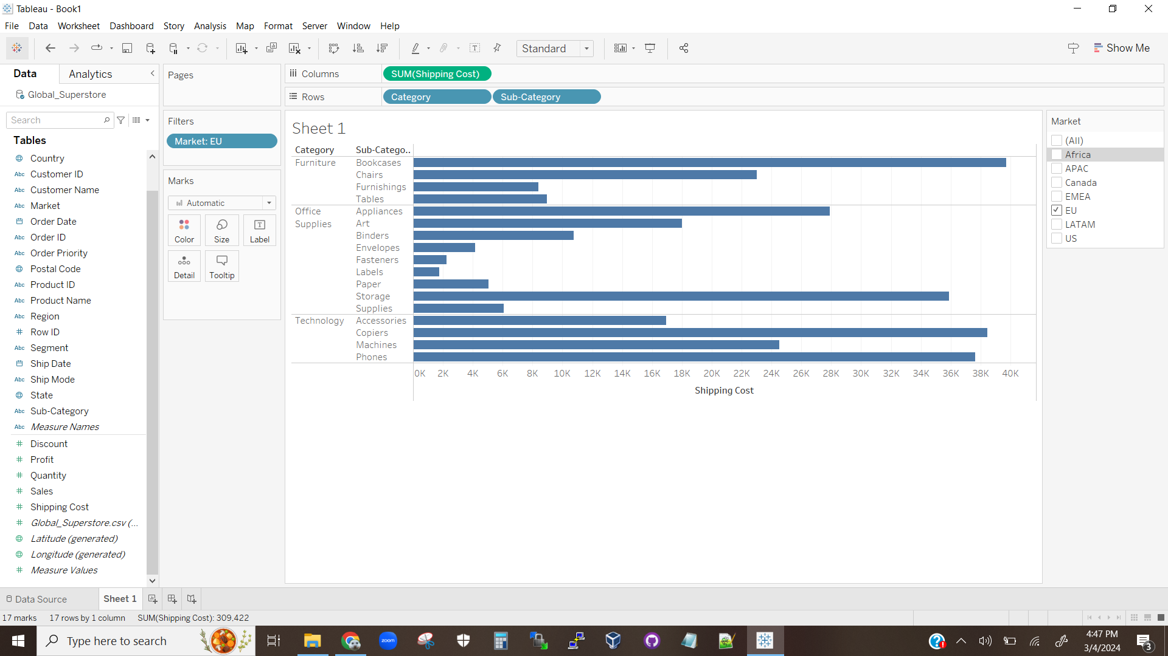

The above visualization shows the total shipping cost of each sub-category for the EU market.

**Visualization 1.3.6**

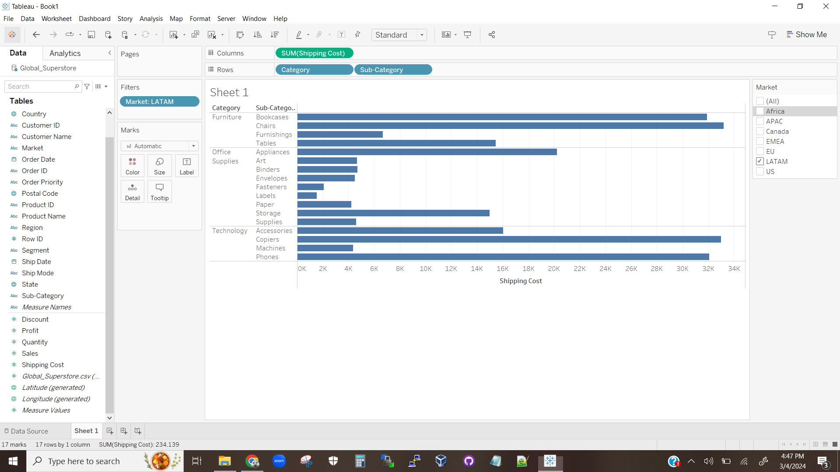

The above visualization shows the total shipping cost of each sub-category for the LATAM market.

**Visualization 1.3.7**

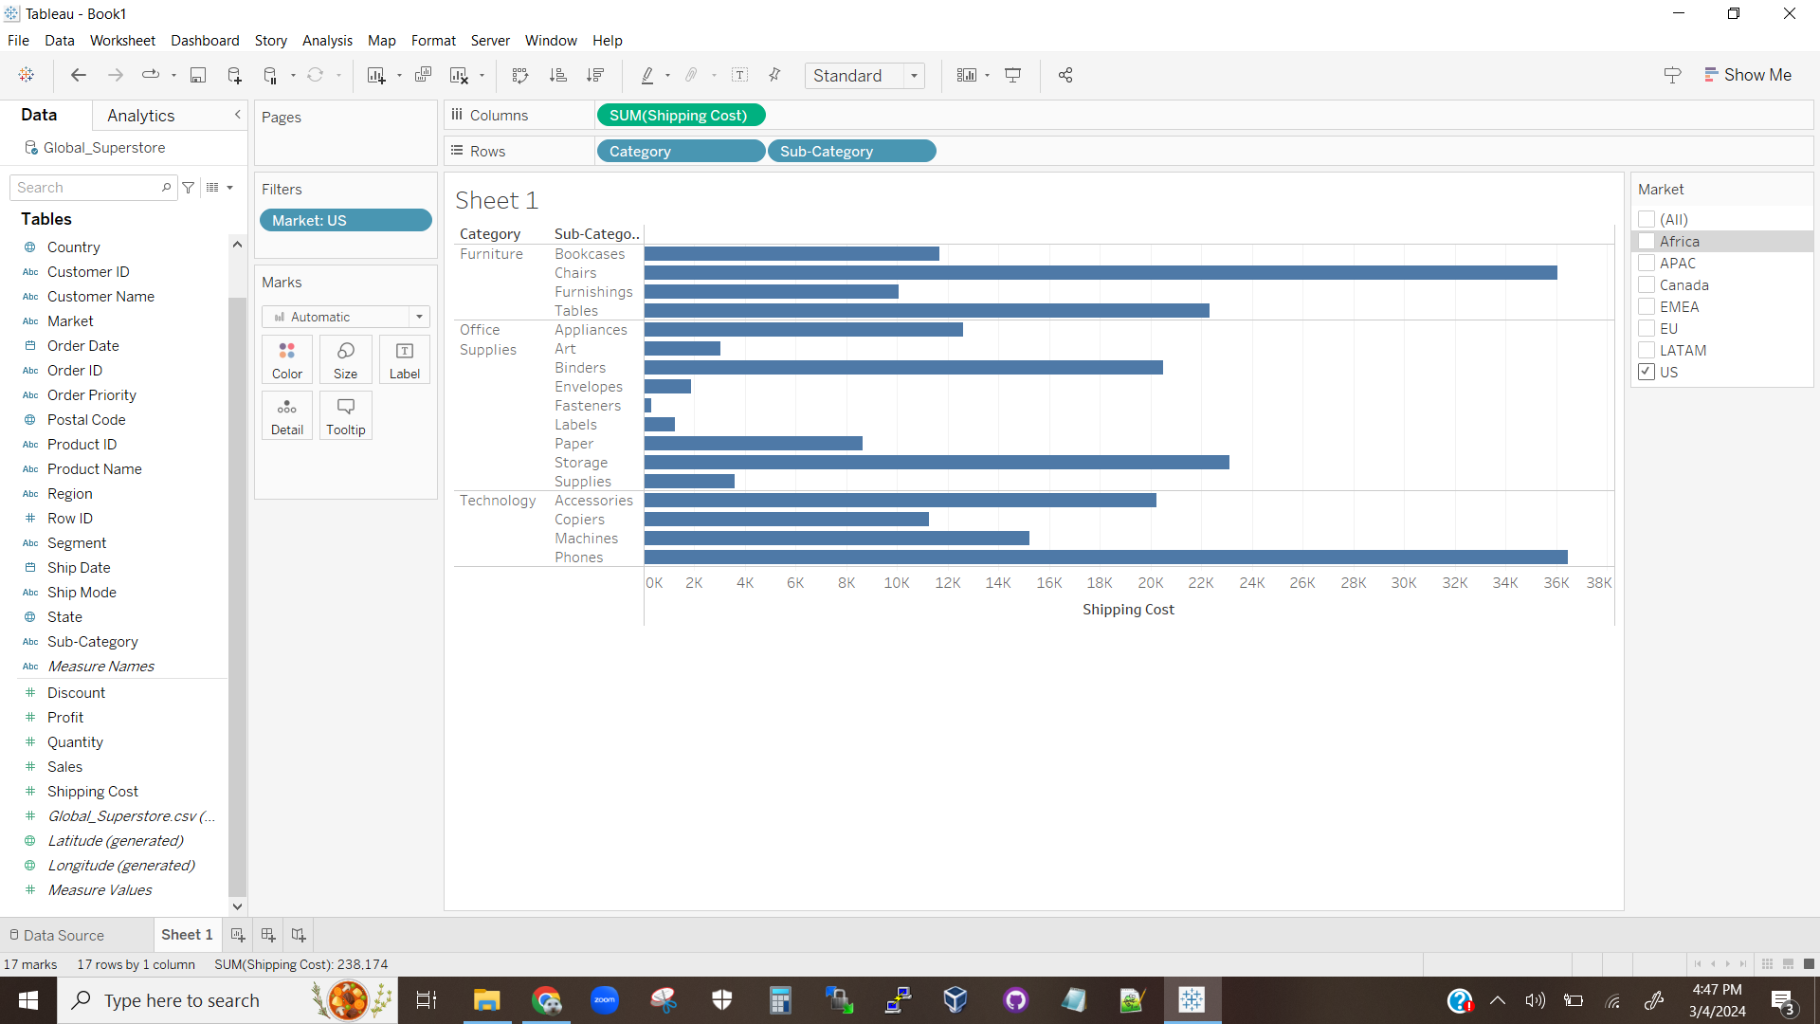

The above visualization shows the total shipping cost of each sub-category for the US market.

For the below markets, the sub-category with the highest shipping costs are:

* Africa: Phones
* APAC: Chairs
* Canada: Storage
* EMEA: Phones
* EU: Bookcases
* LATAM: Chairs
* US: Phones

# Question 2

## Question 2.1

**Visualization 2.1.1**

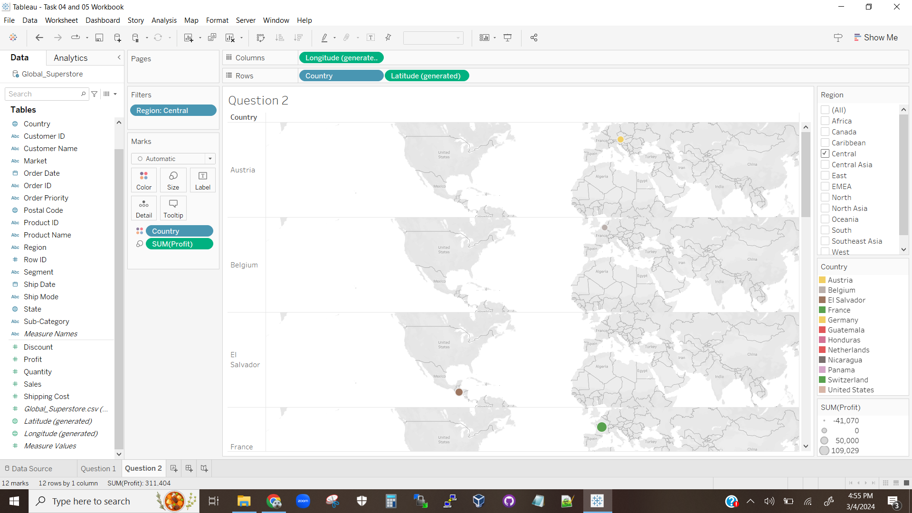

The above visualization shows the latitude/longitude coordinates for each country in the central region with a dot based on the total profit generated in that country.

**Visualization 2.1.2**

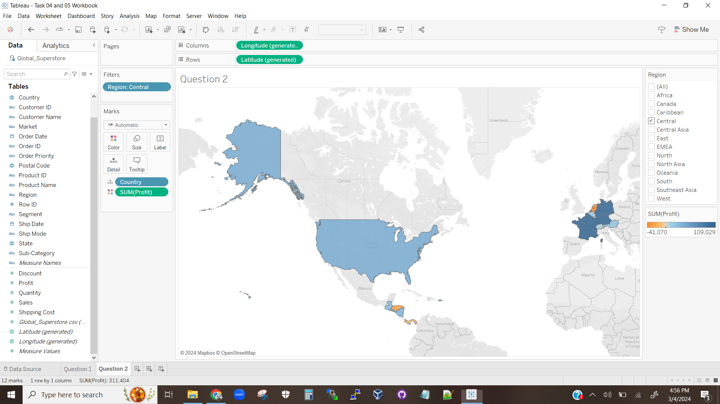

The above visualization shows the profit generated in each country in the central region based on color.

## Question 2.2

Based on visualization 2.1.1 and visualization 2.1.2, we can see that France and Germany are the most profitable countries for this company, with their neighbors being moderately profitable with the exception of the Netherlands. Given that the figures displayed in question 1 showed that these countries have higher shipping costs than others in this region, the high profit is likely due to huge markup in these regions. This implies that the supplies are being made fairly cheaply, and prices are significantly raised in high-socioeconomic countries because the company know the people who live in those countries will still pay the price for their products. The Netherlands’ negative profit could indicate some sort of policy about imports in that country that make selling there unprofitable, or it could be that the sellers cannot set a price for goods that generates profit due to local competitors that don’t have shipping costs as large as this company’s. These same issues could possibly account for the average to negative profits in the USA and Central America. The distribution of profits is also circumstantial evidence that this company is targeting consumers in European countries when designing their products. The different cultures between North America and Europe are significant enough to affect consumer’s product choice. This could be another reason for the profit distribution within Europe as well, as there are significant cultural differences between the neighboring countries.

## Question 2.3

According to visualization 2.1.1 and visualization 2.1.2, Germany is the most profitable country and the Netherlands is the least profitable country.

# Question 3

## Question 3.1

**Visualization 3.1.1**

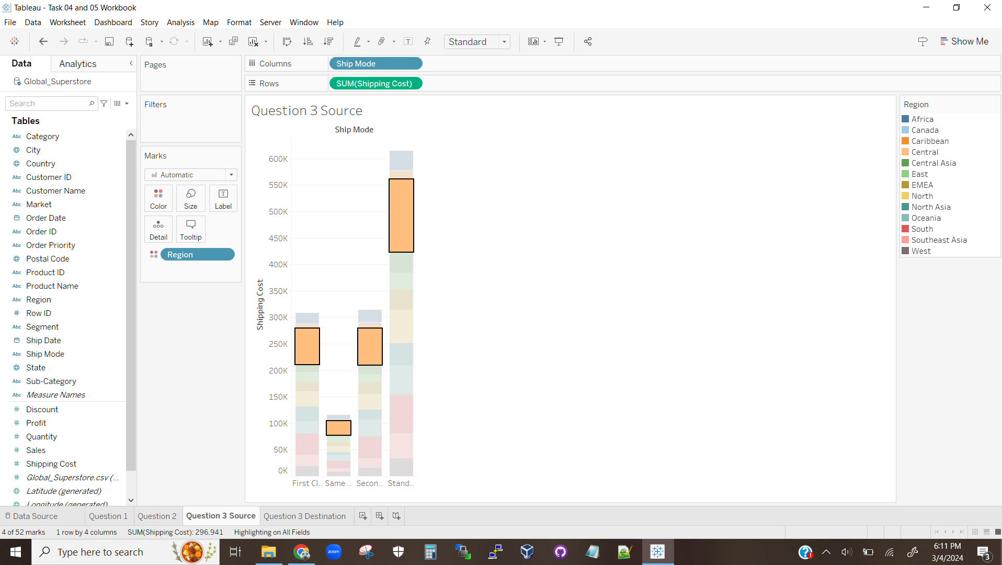

The above visualization is a stacked bar chart depicting the total shipping costs for each shipping mode with the shipping costs depicted by color. The central region is selected for each shipping mode.

**Visualization 3.1.2**

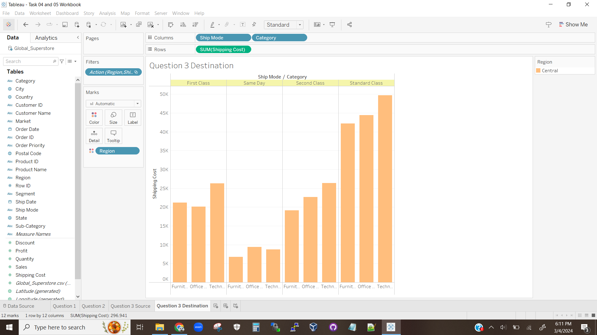

The above visualization depicts a bar chart showing the shipping costs for each shipping mode in each category, as selected by visualization 3.1.1.

**Visualization 3.1.3**

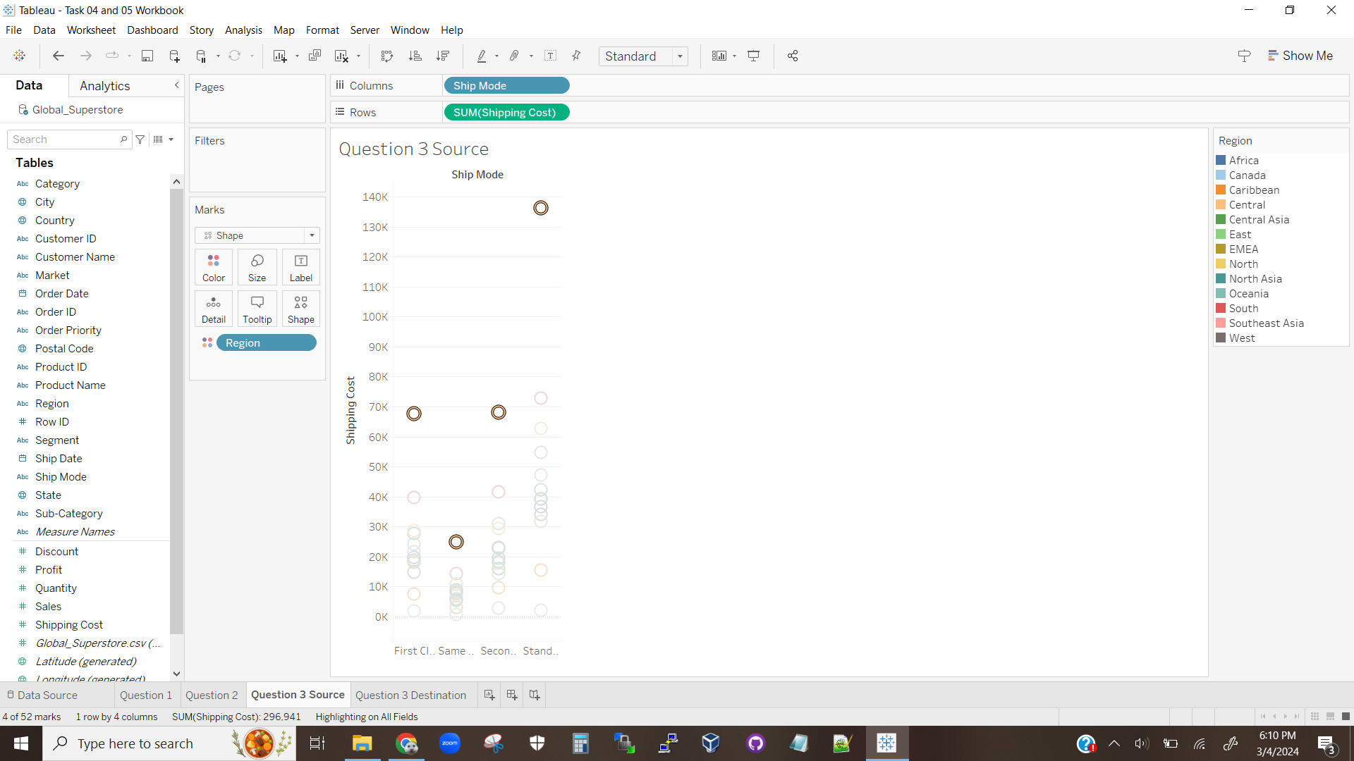

The above visualization is a circle view chart depicting the total shipping costs for each shipping mode with the shipping costs depicted by color. The central region is selected for each shipping mode.

**Visualization 3.1.4**

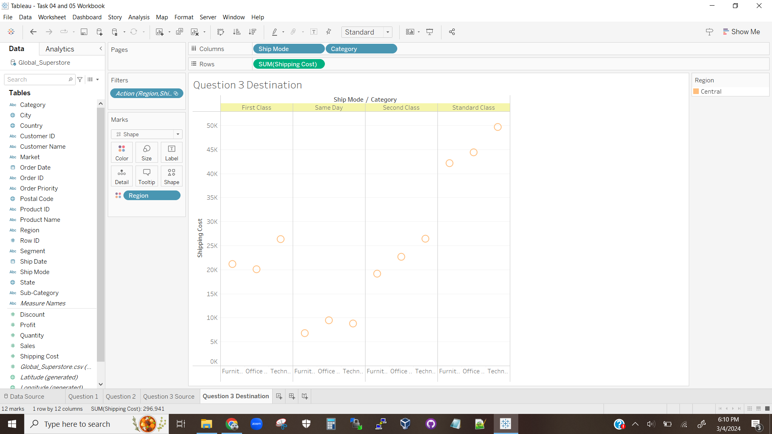

The above visualization depicts a circle view chart showing the shipping costs for each shipping mode in each category, as selected by visualization 3.1.3.

### Question 3.1.2

The above visualizations 3.1.1 and 3.1.3 show the total shipping costs based on shipping mode, with totals for the central region selected. Visualizations 3.1.2 and 3.1.4 show the total shipping costs based on both shipping mode and category, based on the selected central region for the preceding visualization for each visualization in question.

## Question 3.2

### Question 3.2.1

According to visualization 3.1.2 and 3.1.4, the standard class ship mode has the highest shipping costs in the central region in all categories.

### Question 3.2.2

**Visualization 3.2.2.1**

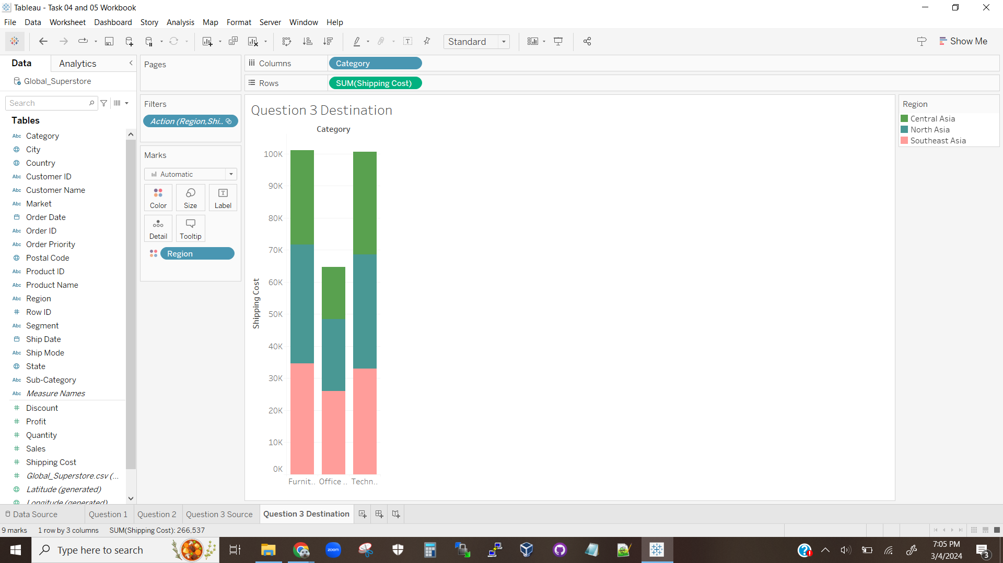

The above visualization shows the shipping costs for north, central, and south asia for each category.

Central Asia has the lowest shipping costs in the Technology category.

# Question 4

## Question 4.1

**Visualization 4.1.1**

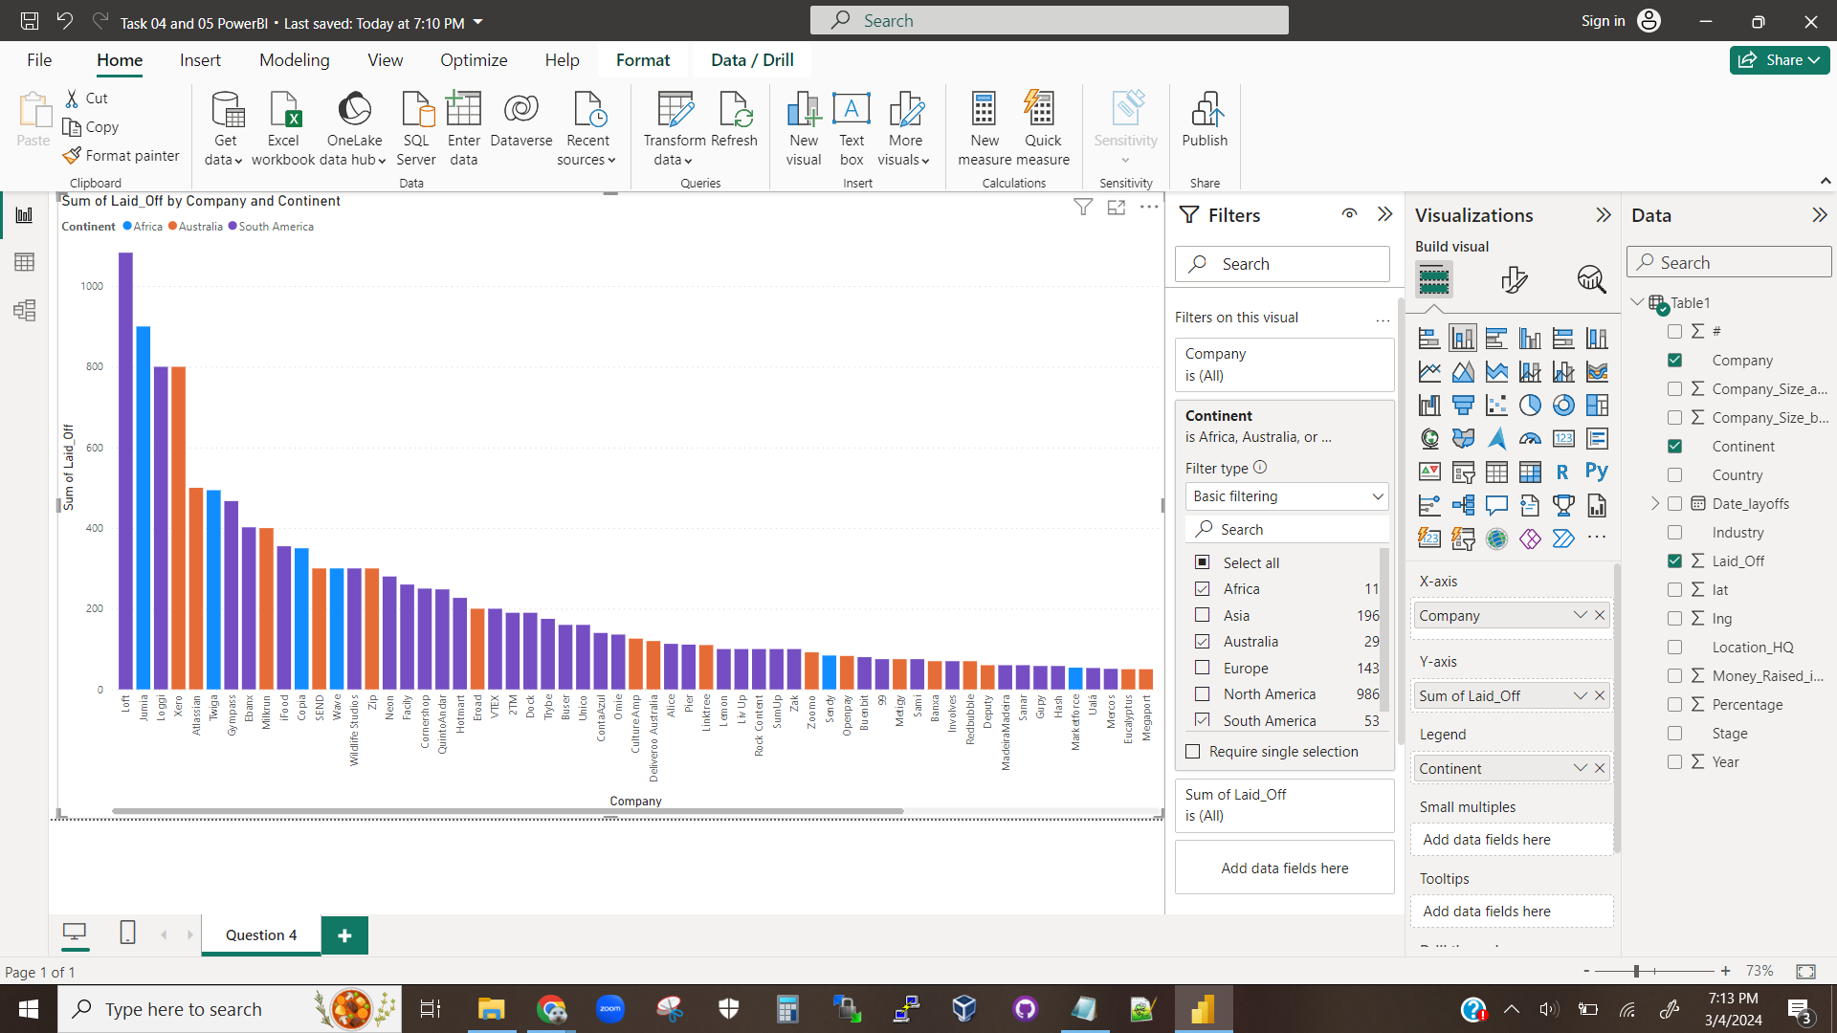

The above visualization is a stacked bar chart showing the number of layoffs each company had, color-coded by the continent those layoffs happened on.

**Visualization 4.1.2**

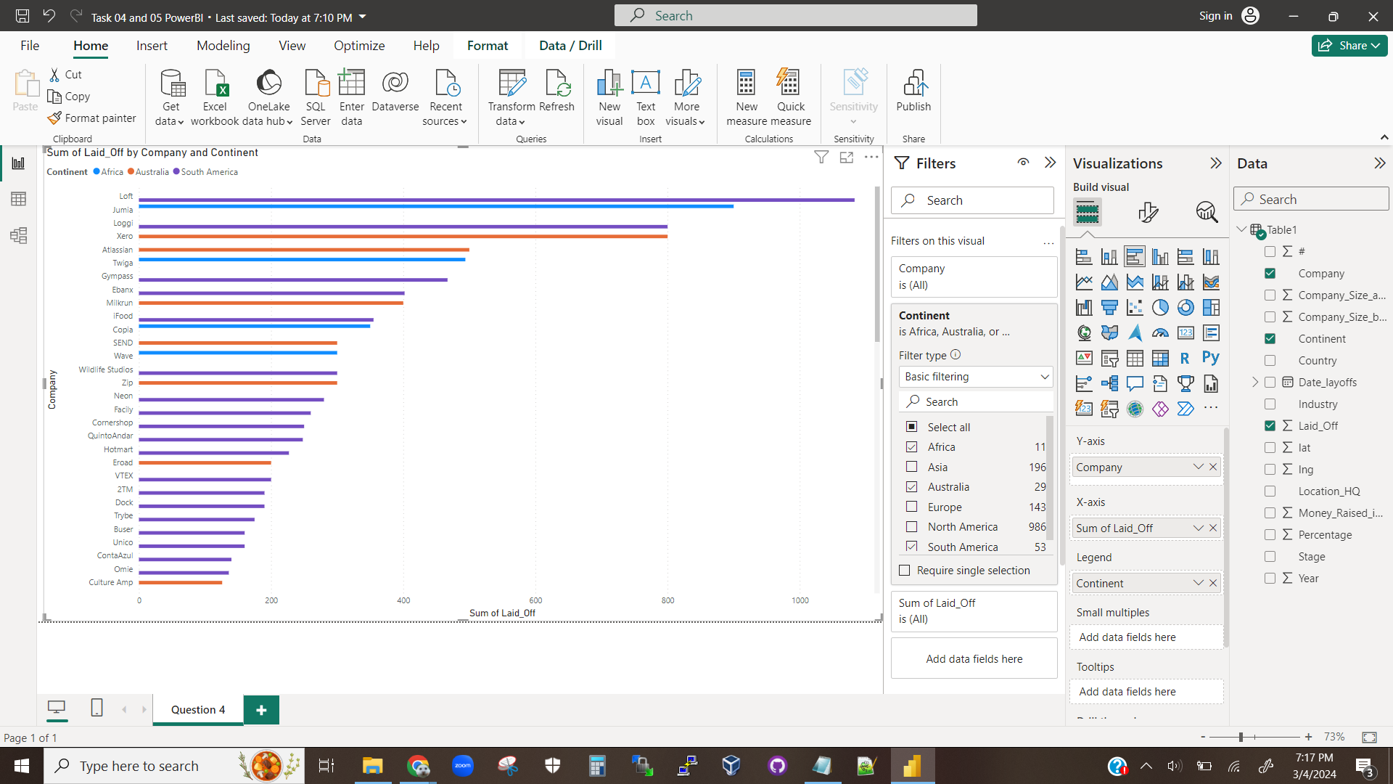

The above visualization is a bar chart (not stacked) showing the number of layoffs each company had, color-coded by the continent those layoffs happened on.

## Question 4.2

Based on visualizations 4.1.1 and 4.1.2, it is clear that none of the represented companies had layoffs in more than one country. Additionally, The companies of Loft, Jumia, Loggi, and Xero are the companies with the most layoffs by a wide margin. South America has the most layoffs in the top 4 by roughly double the country with the next most layoffs. When taking the whole cart into account, South America has more layoffs by a staggering amount.

## Question 4.3

### Question 4.3.1

The legend of a graph tells the reader graph labels that are not placed directly on their components. Usually this is used to pair a label with a color, line type, shading type, etc. This allows a graph to represent data with more than two dimensions. A legend can help a reader understand a graph better by providing more information that wouldn’t be apparent otherwise.

### Question 4.3.2

**Visualization 4.3.2.1**

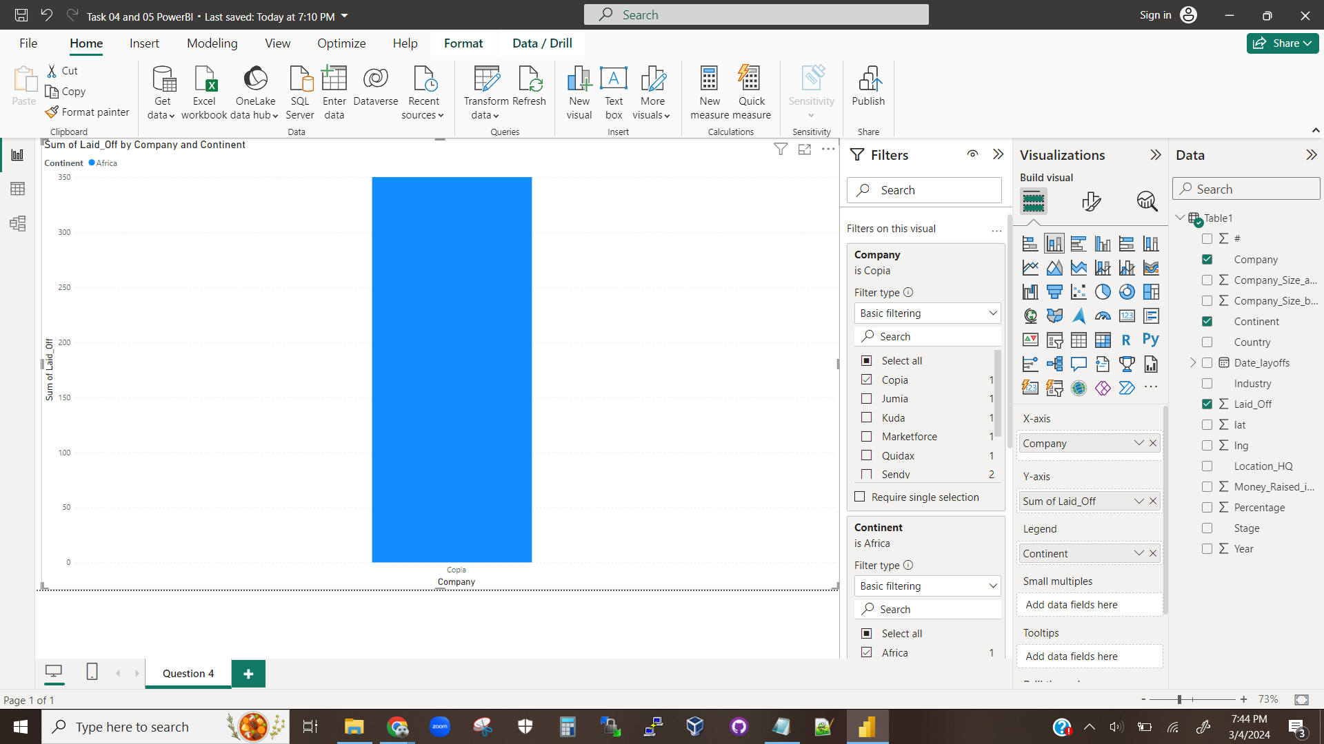

The above visualization is a bar chart showing how many layoffs the company Copia had in Africa.

Copia laid off 350 people in South America.

# Question 5

## Question 5.1

**Visualization 5.1.1**

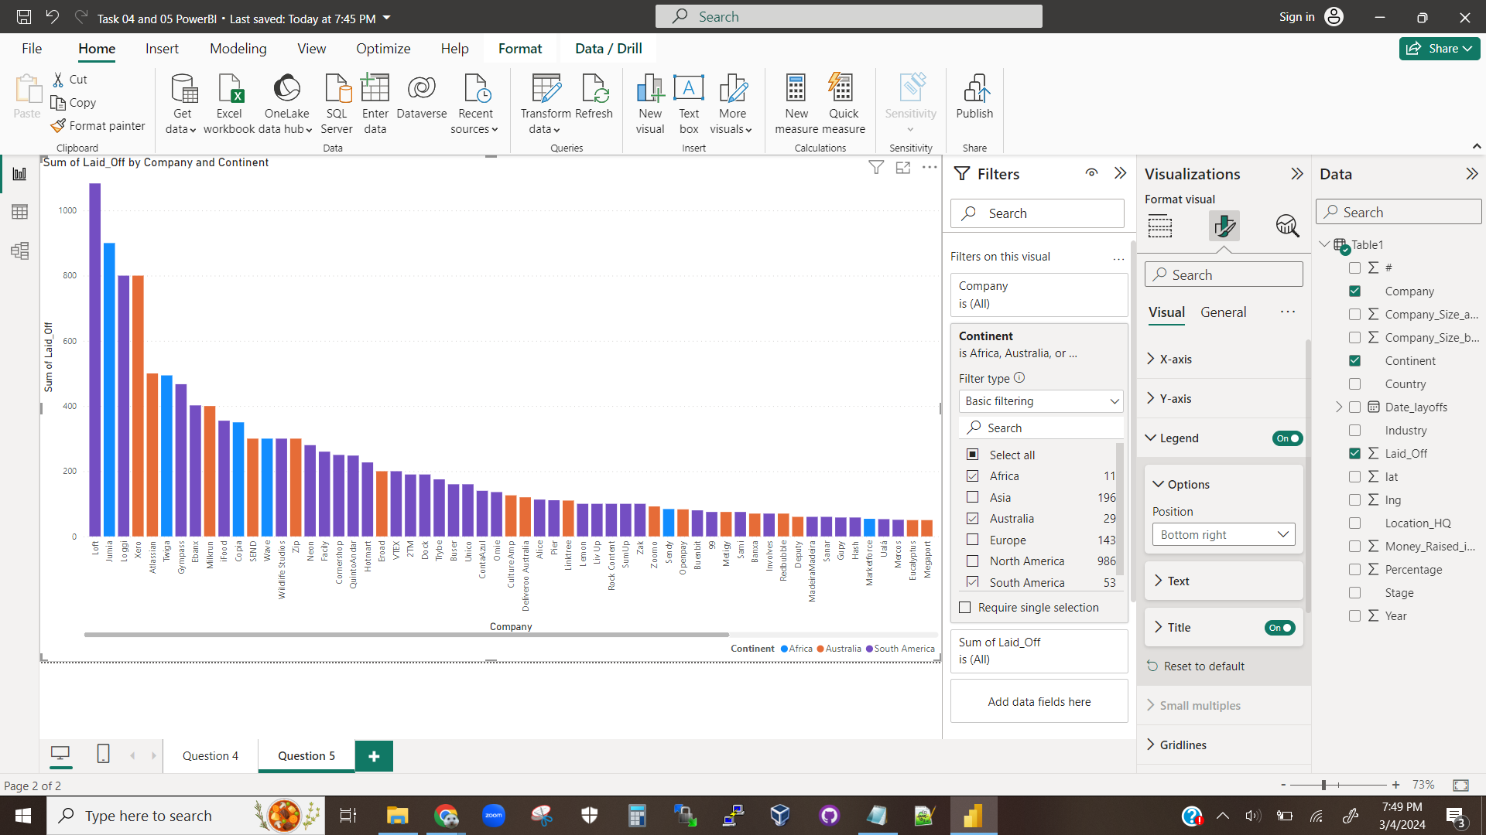

The above visualization shows a bar chart, the same as in Question 4.1, but with the legend moved to the bottom right.

**Visualization 5.1.2**

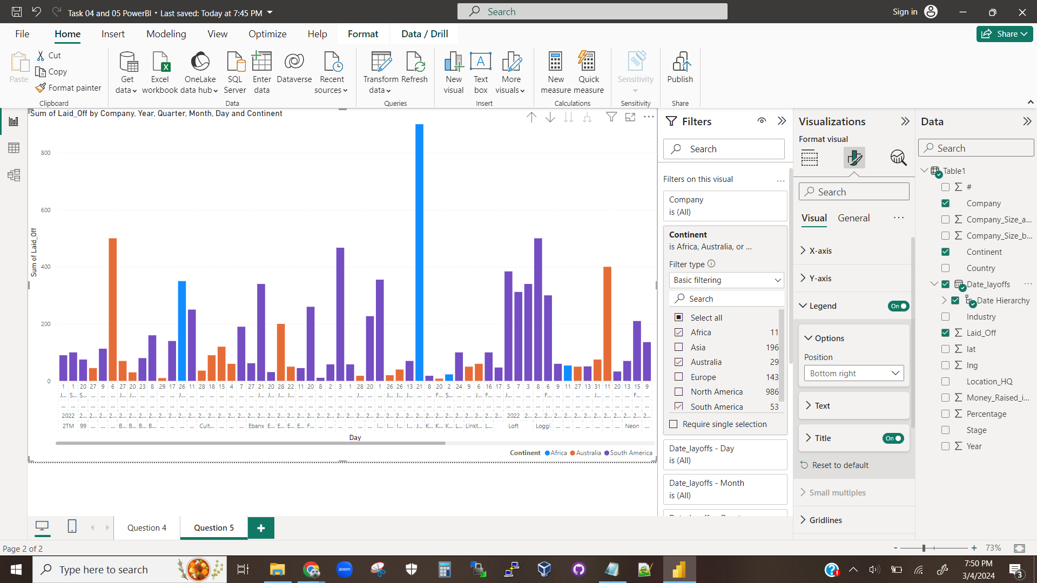

The above visualization shows the addition of the date_layoffs field to visualization 5.1.1, adding dates to the x-axis.

**Visualization 5.1.3**

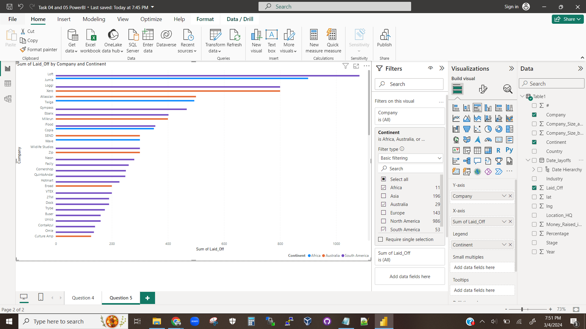The above visualization shows the chart from 4.1.2 with the legend moved to the bottom right.

**Visualization 5.1.4**

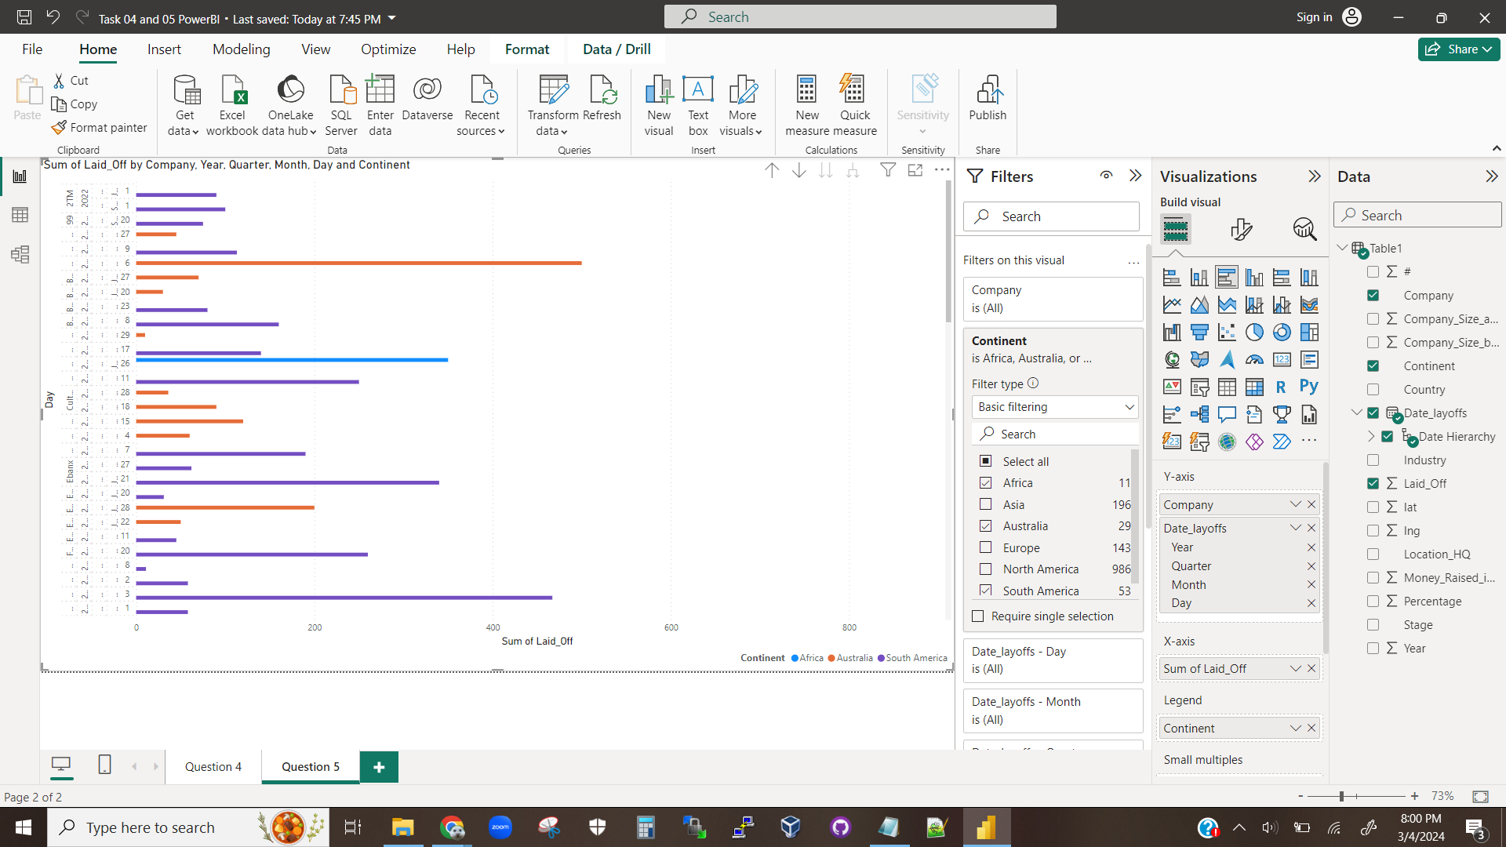

The above visualization shows the addition of the date_layoffs field to visualization 5.1.3, adding dates to the y-axis.

## Question 5.2

The visualizations from question 5.1 show how PowerBI will break down the layoffs of a column by date when the hierarchical field is applied. The most visually apparent change is a reordering of the companies along the x-axis to an alphabetical ordering, rather than an ordering based on layoffs. Most companies still only have one column since they only have one date entry. However, some companies do have multiple dates and for those companies the sum of the layoffs for each date gets its own column.

## Question 5.3

### Question 5.3.1

According to visualization 5.1.2, the Jumia company had the most layoffs during Q4 of 2022.

### Question 5.3.2

**Visualization 5.3.2.1**

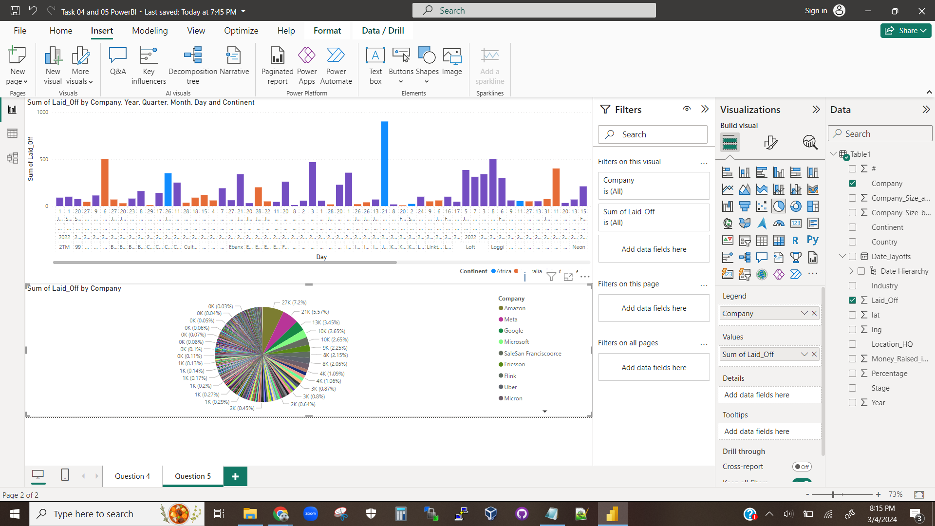

The above visualization depicts multiple visualizations inside of one chart.

Yes, we can add multiple visualizations to a chart.